TASK 15:
class Solution {
public ListNode reverseList(ListNode head) {
ListNode prev = null; // will become new head
ListNode curr = head; // start from current head

while (curr != null) {
ListNode next = curr.next; // save next node
curr.next = prev; // reverse the link
prev = curr; // move prev forward
curr = next; // move curr forward
}

return prev; // new head of reversed list
}
}
Case 1:
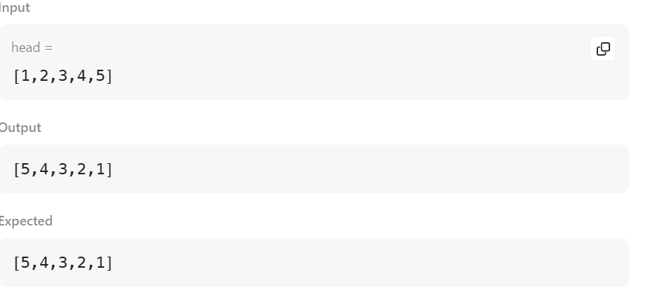

Case 2:
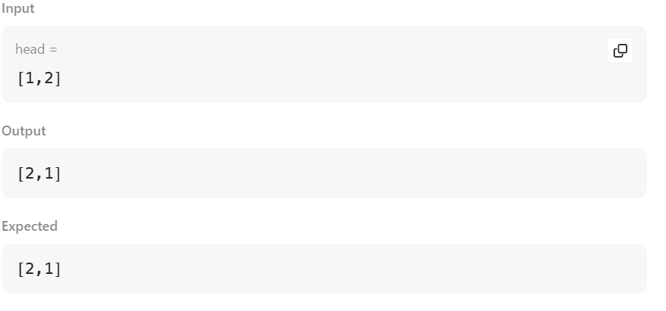

TASK 16:
class Solution {
public ListNode reverseKGroup(ListNode head, int k) {
if (head == null || k == 1) return head;

ListNode dummy = new ListNode(0);
dummy.next = head;

ListNode prevGroupEnd = dummy;

while (true) {
// 1️⃣ Find the kth node
ListNode kth = prevGroupEnd;
for (int i = 0; i < k && kth != null; i++) {
kth = kth.next;
}

// If less than k nodes left, stop
if (kth == null) break;

// 2️⃣ Reverse k nodes
ListNode groupStart = prevGroupEnd.next;
ListNode nextGroupStart = kth.next;

ListNode prev = nextGroupStart;
ListNode curr = groupStart;

while (curr != nextGroupStart) {
ListNode next = curr.next;
curr.next = prev;
prev = curr;
curr = next;
}

// 3️⃣ Connect previous group to reversed group
prevGroupEnd.next = kth;
prevGroupEnd = groupStart;
}

return dummy.next;
}
}

Case 1:
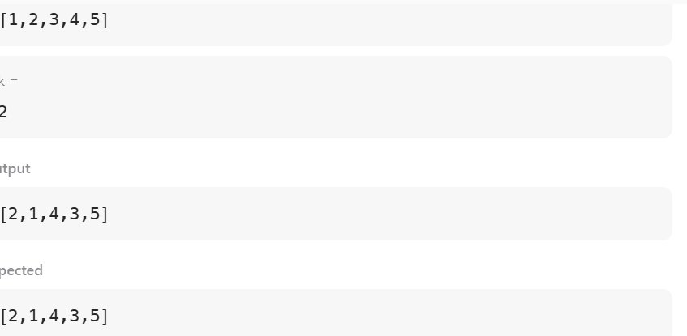

Case 2:
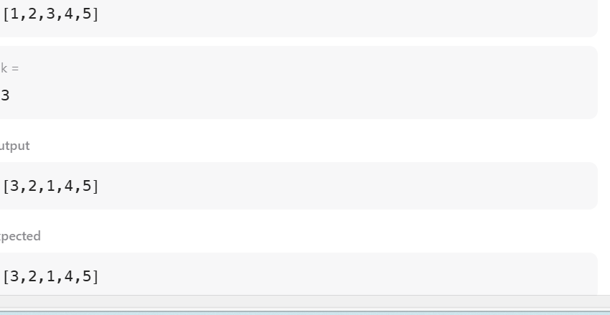

TASK 17:
/**
* Definition for singly-linked list.
* class ListNode {
* int val;
* ListNode next;
* ListNode(int x) {
* val = x;
* next = null;
* }
* }
*/
public class Solution {
public ListNode detectCycle(ListNode head) {
ListNode slow = head;
ListNode fast = head;

// Phase 1: Find meeting point
while (fast != null && fast.next != null) {
slow = slow.next;
fast = fast.next.next;
if (slow == fast) {
// Phase 2: Find cycle start
slow = head;
while (slow != fast) {
slow = slow.next;
fast = fast.next;
}
return slow;
}
}
return null;
}
}

Case 1:
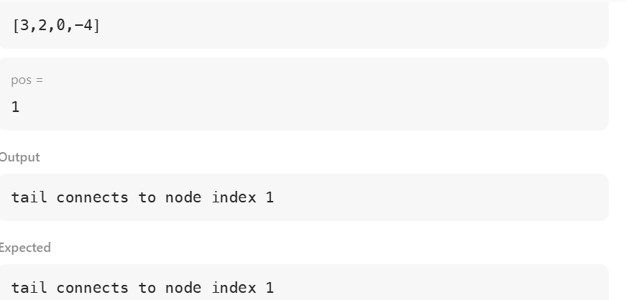

Case 2:
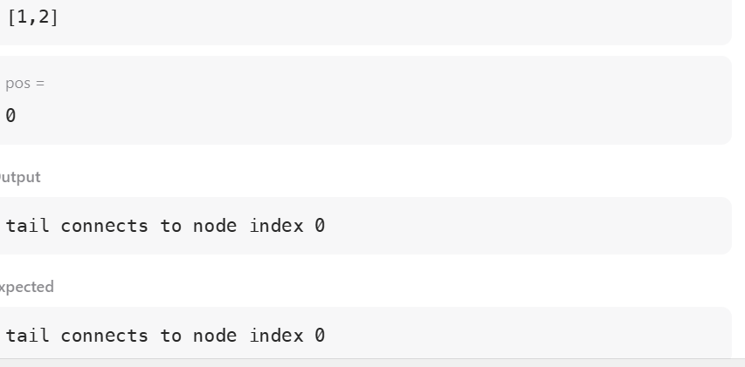

TASK 18:
/**
* Definition for singly-linked list.
* public class ListNode {
* int val;
* ListNode next;
* ListNode(int x) {
* val = x;
* next = null;
* }
* }
*/
public class Solution {
public ListNode getIntersectionNode(ListNode headA, ListNode headB) {
ListNode a = headA;
ListNode b = headB;
while (a != b) {
a = (a == null) ? headB : a.next;
b = (b == null) ? headA : b.next;
}
return a;
}
}



Case 2:
